The Great Cameron Clear Out
The Catalogue
As some will know already, I am obliged to downsize in a drastic way, and this has caused me to sort out all my conchological material, be it actual samples, or the array of equipment that we use in the field and indoors, especially if, like me, you have kept and attempted to curate a collection. The actual shells are accounted for, with all but those I am currently working on offered to museums. There are more than 4,000 lots duly listed and labelled.
Equipment is another matter. I was an early adopter of the now fashionable business of working from home, as for most of my working life I was in Adult Education Departments that did not provide either laboratories or equipment. I did get some help with equipment, but I accumulated stuff from many sources, made some myself, had presents from family (wouldn’t you be delighted if your children gave you a few hundred tubes or display boxes for Christmas?).
What I thought would be a trivial task turns out to be a monster. The volume and variety are both immense. I have sorted and packed all this stuff, keeping only a little for myself, as I have not given up on fieldwork in this country. Now, I want to dispose of it, hopefully by reuse rather than recycling. So, I am soliciting “bids” for “lots” like an auction. The difference is, that with a few exceptions, it is all free; I do not want to make any money. However, I do hope for donations to either the Conchological Society or to Sorby Natural History Society roughly proportional to the amount and character of the material removed.
Accordingly, I have grouped the lots by guessed at value. At the cheapo end, I would hope for a donation of £1.00. At the top end, I would look for £30.00. A few individual items are “priced” separately. I will accept bids offering no donation, but they will be trumped by anyone offering the appropriate sum. Small payments can be cash on collection. For larger sums, a cheque made payable to the relevant society is preferred. Receipts will be given for cash.
I am unwilling to split lots; too much hassle. Equally, I will not post anything, and in any case the glass items are not packed to meet the rigours of postal delivery. I am willing to deliver to addresses within 30 miles of Sheffield if the donation offered exceeds £25. Otherwise, I would expect the bidder to collect personally from my home. (At present, apart from cost, many hours away from home is difficult). Clearly, I hope that people will want a number of lots to make their journey worthwhile.
I have tried to liven up the catalogue with a few comments on some items. There are pictures too! (not of everything) I have attempted to divide the lots by possible function: in the field, or indoors, when processing, storing or displaying, but many items might be multi-purpose. Glass is not for the field!
Each lot has a number, and there is an order form at the end. Some very numerous items have been split into several lots. I have often made up a lot, only to find more of the same lurking in the cellar. I have simply made another lot. Bids will be registered as they arrive. Bids offering the suggested donation will be accepted at once, and later bids told that they had failed. After one month, “empty” bids will be accepted if no other offers have been made. I really do not want to take stuff to the recycling centre. Pictures are grouped on two pages at the end of the catalogue, but before the order form.
Feel free to share this with others, even a hard-up institution. £500 secures the lot, but be aware that it would need a van rather than a car to take away. Email is preferred for all communication:
radc@blueyonder.co.uk But you can phone or text to 07913 705 559, or by post to 2 Victoria Road, Sheffield S10 2DL

Special Items
These lie outside the general lists.
Lot 1. A set of 18 library card index drawers, modified to house shell collections. Each drawer has been modified to hold a second shelf (see pictures); These are hand made and robust. Each drawer has thin card open-top boxes made to fit, so that segregation of species is easy. As a tower nine drawers high, it reaches 1.13 m. It has 4 sets of 4 drawers and one of two drawers. Well-made and ornamental. £100 secures the lot automatically, but bids of £50 and upwards will be considered. I am not parting with these for nothing!
Lot 2. A set of drawers in a stack made up of the drawer parts of cheap office desks (picture). These have a home-made top. 7 drawers, standing just over a metre high. A bit scruffy, but have held a lot of samples. £20 secures them, bids of £10 or over considered.
Lot 3. Two sets of three drawers of what I believe were cabinets designed for storing medical x-rays (picture). Width c.1.15 m, Depth c 88 cm, Height in each drawer c. 5 cm. Bought at a junk shop in Abbeydale Road more than 25 years ago! They stored the bulk of my collections other than those from Madeira and the Azores. £20 secures them. BUT: these are bulky items, at present on the first floor. I am not as fit as I was, and the ability to move them is needed.
Lot 4. A collection of specimens of 61 Greek land snail species given to me by Moysis Mylonas after my first collaboration with him in 1993 (!). As they are mostly single specimens, and lack locality data, I have not offered them to a museum. Bear in mind that there have been taxonomic revisions since, though I do not think they are very significant here. I am not asking for a minimum, rather, I would like to think that it went where it was useful. SOLD!

Trays as Storage Items
Lots 5-9. Tough cardboard trays each c. 8cm x 5 cm, walls c. 2cm (Picture). Five lots of c.52 trays in each. £3 secures a lot.
Lots 10 & 11. Similar trays, but 15 cm x 10 cm (picture) Two lots of c. 50. £4 secures a lot.
These trays were sold by the Rock Shop in Sheffield for storing/displaying rock and mineral samples by amateur geologists. They housed most of my European, American and Australian samples in the x-ray drawers listed earlier,
Lot 12. 36 hand-made trays in strong cardboard, in various sizes and colours (picture). £2 secures. (made before I discovered the Rock Shop.)
Lot 13. A set of 10 plastic trays with lids, each c. 17 x 17.5 cm divided into 12 compartments (picture). Good for small tubes 5 cm tall. £10 secures.
Lot 14. A set of 5 plastic trays, no lid, each 34 x 21 cm divided into 15 compartments (picture). £6 secures.
Trays for sorting/processing
Lot 15. 10 aluminium trays for sorting or drying litter samples each c. 30 x 22 cm. Metal so that they can safely stand heat for rapid drying. £15 secures.
Lots 16-18. Plastic Petri Dishes (with lids), successively with 48, 42 and 36 dishes in each lot. £2.50, £2, and £1.50. Many well used, and a bit opaque, but not all; some are “virgin”. (Lots determined by the sizes of cardboard boxes available!)
Lots 19 & 20. Each 30 of 10 x 10 x 2cm plastic boxes divided into 25 compartments (750 compartments in each lot) (picture). £ 5 each secures. I used these to get tiny Caseolus species from Porto Santo adjacent to each other from different sites. Put on the right way, the lid prevents stuff moving compartments.
An aside: Because most of lots 15 to 20 have been used, I have learnt two lessons. Adhesive tape (no trade names, no litigation) does not last forever, but when it decays, the tape parts from the adhesive, but the adhesive does NOT part from the plastic, and is remarkably difficult to remove. Surgical spirit is some use, but white spirit causes seams in the plastic to come apart. Further, different makes of permanent marker differ in the ease with which they can be removed. Some are literally permanent, unless you use an abrasive. Others will come off with surgical spirit, but not with 70% ethanol (I had a little, from working in museums abroad). You will find faint relics of past use on some. More to say when we come to plastic lunch boxes for live material.
In the Field (or for storage)
Lot 21. 40 sturdy plastic pots with screw top lids, each about 7 cm deep, diameter c 6.5 cm (slightly tapering, so stackable (picture). A cut above the standard urine sample pots that are available everywhere. £12 secures.
Lot 22. 37 plastic pots with screw top lids, in a variety of sizes from 6 cm depth and 6 cm diameter to 3 cm x 3 cm. £5 secures.
Lot 23. 100 standard plastic sample pots with screw top lids (Picture). 8 cm tall inside, c 2.8 cm diam. Well-used. £6 secures.
Lots 24 & 25. Two sets of 40 coated metal pots, 10 cm tall, diam c.7.3 cm, with screw top lids and a good seal (picture). Mostly unused. £10 each lot secures. These pots were for the University of Dundee Greenland expedition many years ago. I was not involved, but happy to accept their unused items. Too happy, since few have been used.
Lot 26. 100 cylindrical plastic pots with screw tops, 6 cm deep, diameter c. 4.cm (picture). Many unused. £20 secures.
Lot 27. 45 cylindrical plastic pots with red screw tops, 6 cm deep, c.3 .7 diameter (picture). £9 secures.
Lot 28. 86 small plastic tubes with stoppers, c 5 cm deep, 1.3 cm diameter (picture). £ 6 secures.
Lot 29. 27 large plastic sample pots with various lids. Roughly 7 cm deep, diameter at base c 5cm. The standard medical specimen pots, mostly bought in Poland. Not as robust as lot 26, but serviceable and with the advantage that they taper, and can be stacked for storage. Lids tend to be brand-specific, so they are not stacked here. £4 secures.
Lot 30. Plastic, screw top tube miscellany: 56 small, h=5cm diam c.1.5; 6, same diameter but 9.5 cm high; 10 sample pots as lot 23. £3 secures.
Lot 31. Plastic snap top miscellany: 15 small, 5.5 c h, diam c. 2 cm. 6 larger, same height, 2.7 cm diam. £1 secures
Lots 32-36. Five lots of 100 tiny plastic screw-on tops, nearly all “virgin”. H = c 4.5. internal diameter = c.0.8 cm (picture). Very transparent, but robust wit a good seal. Scarcely for use in the field, but good for holding tiny species. Labels can be read through the plastic. £5 secures a lot.
Lot 37. Total plastic ragbag of c. 40 items, many without lids. BUT: includes 3 cylindrical collecting pots with pull-off lids, each c. 11 cm tall and diam c. 7.2 cm. If you have romance in your soul, these have seen many Greek islands, passed down many field trips. £1 secures. Go on, add this to your order!
Glassware
I guess not usually for use in the field. Mostly what might be called tubes or vials, and some bought with the idea that they would be the final resting place for shells arranged in a collection. Lots 39 and 41 have a particular resonance for me, as they housed my very first collection of UK land snails, following a field course on the Gower in 1965 or 1966. A few may retain numbers from my original collection, which fitted in a box not much larger than a shoe box.
Lot 38. 100 robust glass tubes with black screw on lids, which do not protrude beyond the glass, so that they can be arranged horizontally. Height, 5 cm. interior diameter c 0.9 cm. £12 secures.
Lot 39. 81 glass tubes in the same series as lot 38, but height 6 cm, diam (internal) c. 1.2cm £10 secures.
Lot 40. 22 glass tubes in the same series as lots 38 & 39, but height 7.5 cm, diam 2,2 cm. There are also 5 more lacking lids, and 4 sturdy bottles 6 cm high, internal diam c.2.8 cm.£3 secures.
Lot 41. 37 glass tubes in the same series as lots 38-40, but 10 cm tall. Diam c. 1.9 cm. £5 secures.
Lot 42. 83 flat bottomed glass tubes 7.5 cm high, diam c.2.2, with plastic stoppers. £6 secures.
Lot 43. 24 miscellaneous flat bottomed glass tubes, c. 7 cm high and various diams (0.8-1.7 cm). No stoppers. £2 secures.
The next 6 lots represent my efforts to standardise the height of tubes to fit neatly in a collection cabinet. All are 5 cm tall (or less for some tiny tubes). Because I kept the mouth closed with cotton wool rather than stoppers, some stoppers have disappeared. This is noted. Larger species were put in boxes.
Lot 44. 100 flat bottomed tubes 5 cm x 2.5 cm diam, with plastic stoppers. £6 secures.
Lot 45. 92 flat bottomed tubes identical to lot 44. £5 secures
Lot 46. 200 flat bottomed tubes 5 cm high x c.1.8 cm diam, with stoppers. £12 secures
Lot 47. 92 flat bottomed tubes 5 cm high x c.1.1 cm diam, with stoppers. £5 secures.
Lot 48. 72 flat bottomed tubes 5 cm high x c.0.8 cm diam. There are enough stoppers, but these seem to come from different manufacturers, and not all fit the stoppers. £4 secures.
Lot 49. 23 tiny flat bottomed tubes, various, but none with diam greater than 0.5 cm. No stoppers. £1 secures.
Lot 50. 100 tiny round bottomed tubes, 5 cm high x c.0.5 diam. These have a slight rim at the mouth, and are made of soda glass, I think a bit more fragile than the rest (cheaper, too). No stoppers. £6 secures.
Lot 51. A miscellany of 194 round bottomed tubes, of which 140 are tiny: 4 cm high x 0.5 diam. The larger ones are up to 10 cm high and 2 cm diam. Most are smaller. No stoppers. £8 secures.
Lot 52. 20 glass vials with screw tops. C. 4 cm high x c.1 cm at neck (a little wider below) £1 secures.
Lot 53. 85 glass vials (I take a “vial” to be a tube with a constricted neck) 7 cm high x c. 1.8 cm diam (There are a few oddities. Snap tops, loose in box. £5 secures.
Lot 54. 105 glass vials, all c.1.8 cm diam, with snap on tops. 41, 5 cm tall; 38, 4 cm; 26, 3.5 cm. £6 secures.
Lot 55. 14 sturdy glass jars with screw top lids (2 are missing the card liner to the lids) 7 cm high, inside diam c. 5 cm. £ 4 secures.
Lot 56. 100 large glass tubes, 10 cm high, diam c.2.4 cm, plus 8 misc smaller tubes. No stoppers, but I have added 31 corks that fit some (I think there are different makes here). £6 secures.
Display/storage boxes
Lot 57. 66 rectangular transparent plastic boxes with sliding or hinged lids. Sliding: 18 at 4.5 x 3.3 x 1 cm; 26 at 6 x 4 x 1.5 cm; 17 at 7.5 x 4 x2 cm. 5 misc hinged. I think these are “early” efforts to produce such boxes, and they are not of the quality of later lots. £7 secures.
Lot 58. 112 transparent plastic boxes, of better quality than lot 57. Square boxes (all 7 x7 cm); depth 2 cm, 11; depth 3.5 cm, 3; depth 5 cm, 7 + one odd. Rectangular 7 x 6 x 3.3 cm, 3. 7.5 x 5.5 x 2.5, 31 (not all identical); 5.5 x 3.5 x 2 cm, 56. All have lids that push on or down. These are often unused and in very good nick. £30 secures.
Lot 59. 18 large, loose lidded transparent plastic boxes. 13 at 7.5 x 6 x 4 cm; 5 at 12 x 7.5 x 4 cm. Courtesy of my Polish colleagues. Very robust, and good for large shells. £5 secures.
Lot 60. 26 Black card museum display boxes with glass lids (picture) 14 at 9 x 6 x 3 cm; 10 at 11 x 7.5 x 3.5; 2 at 12.5 x 8.8 x 5 cm, 1 at 15 x 10 x 4. £13 secures.
Lot 61. 124 black card museum boxes with glass lids. A range of sizes: 50 at 4.4 x 3 x 2.5; 2 at 6 x 3 x2; 4 at 6 x 4 x 3.5; 3 at 6 x 4 x 5; 35 at 6 x 4 x 2.5; 18 at 7 x 4.5 x 2,3; 12, miscellaneous sizes, largest dimension 8.5 cm. £30 secures.
Lot 62. 66 round, black museum display boxes, 60 with glass lids, 6 with card lids. Various depths, diameters: 2 at 4.7 cm; 22 at 4 cm; 15 at 3 cm; 21 at 2.5 cm. £15 secures. I hope someone has room for these antiques, mostly discards from the NHM in London. They are works of art. I guess making round boxes was less labour intensive than rectangular ones. Could be props in an historical drama about Darwin!
Transparent plastic lunch boxes (bought to keep live animals for crowding experiments)
Lots 63 & 64. Each with 40 small square boxes (10 x 10 cm, 7 cm deep, slightly tapered so can stack) and 16 large rectangular boxes (22 x 12 cm, 8 cm deep). Also tapered, and can stack. £15 secures each. Some have indelible marks. One lid says “Slowdini”, not in my writing, and I wondered if it was foreign. Then the penny dropped: Slow and Houdini: an escape artist
Oddities (I am not sure they would be wanted, but just in case!)
Lot 65. 54 very robust miniature glass bottles, rectangular with rounded edges, 5 x 2 x 3 cm, and with a neck c. 1.5 cm wide and a metal screw top. Originally used to store tiny beads for “beadics”, the simulation of genetic drift and gene flow in the dear dead days before computers were widely available. Also to get an adult class on their hands and knees in Atherstone Library, discovering about the functional response of predators and the significance of handling time. Onlookers from the street must have feared some weird cult. £10 secures.
Lot 66. 39 Old fashioned, waxed card pill boxes (picture). Useful for material alive or with bodies, because not airtight, so everything dries out rather than smelling. £2 secures.
Sometime, much later in the year, there will another lot, much smaller and less varied, as I sort a few samples not fully dealt with.
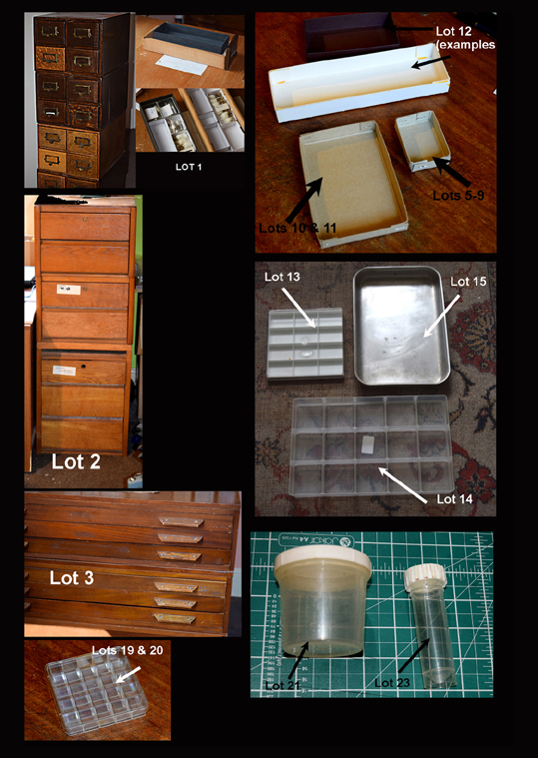

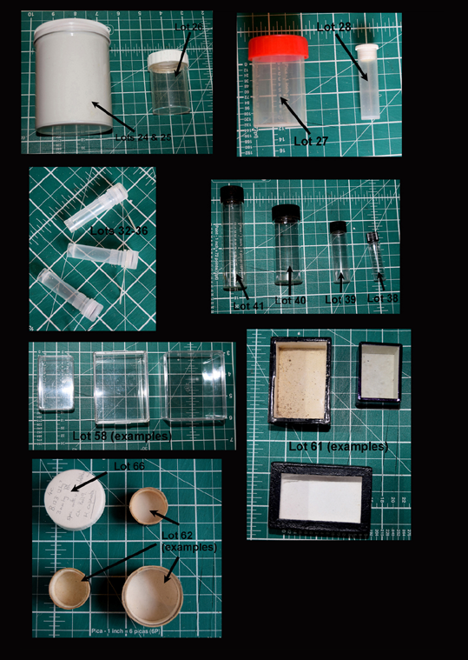

Order form (not for the special items; please bid for these separately) Note that you are free to bid any amount, even nothing if Scrooge is in your ancestry (the proceeds go to your Society, not to me), but the first bid that meets the threshold will beat others. Do remember that you will have to collect yourself, unless you order at least £25 worth and live within 30 miles of Sheffield. I will notify you to tell you whether your order was accepted in full, in part or not at all. Cash is OK for small orders, but a cheque or bank transfer to the Society can be arranged.
Name
Contact (email preferred)
Lot | Secures | Offer |  | Lot | Secures | Offer
5 | 3.00 |  |  | 36 | 5.00
6 | 3.00 |  |  | 37 | 1.00
7 | 3.00 |  |  | 38 | 12.00
8 | 3.00 |  |  | 39 | 10.00
9 | 3.00 |  |  | 40 | 3.00
10 | 4.00 |  |  | 41 | 5.00
11 | 4.00 |  |  | 42 | 6.00
12 | 2.00 |  |  | 43 | 2.00
13 | 10.00 |  |  | 44 | 6.00
14 | 6.00 |  |  | 45 | 5.00
15 | 15.00 |  |  | 46 | 12.00
16 | 2.50 |  |  | 47 | 5.00
17 | 2.00 |  |  | 48 | 4.00
18 | 1.50 |  |  | 49 | 1.00
19 | 5.00 |  |  | 50 | 6.00
20 | 5.00 |  |  | 51 | 8.00
21 | 12.00 |  |  | 52 | 1.00
22 | 5.00 |  |  | 53 | 5.00
23 | 6.00 |  |  | 54 | 6.00
24 | 10.00 |  |  | 55 | 4.00
25 | 10.00 |  |  | 56 | 6.00
26 | 20.00 |  |  | 57 | 7.00
27 | 9.00 |  |  | 58 | 30.00
28 | 6.00 |  |  | 59 | 5.00
29 | 4.00 |  |  | 60 | 13.00
30 | 3.00 |  |  | 61 | 30.00
31 | 1.00 |  |  | 62 | 15.00
32 | 5.00 |  |  | 63 | 15.00
33 | 5.00 |  |  | 64 | 15.00
34 | 5.00 |  |  | 65 | 10.00
35 | 5.00 |  |  | 66 | 2.00
 | Total | £ |  |  | Total | £
 |  |  |  |  | Grand total | £

